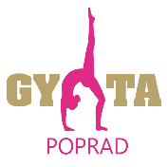
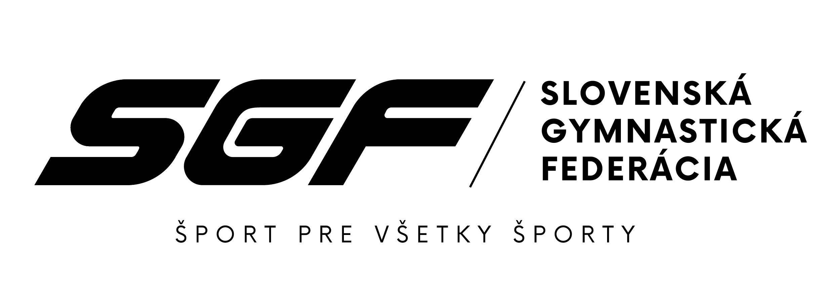
SLOVAK GYMNASTICS OPEN
24th – 25th November 2023, Poprad (SVK)

Form to be sent to: zbynovacova@sgf.sk
Deadline: 25th October 2023
Organizing Committee / Host Federation
Slovak Gymnastics Federation
Junácka 6
832 80 Bratislava

Nominative registration

Federation |  | Contact person:
Federation |  | Phone:
Federation |  | E-mail:

OFFICIAL DELEGATION
function | name | surname | date of birth
WAG Senior gymnast 1
WAG Senior gymnast 2
WAG Junior gymnast 1
WAG Junior gymnast 2
WAG Coach |  |  | -
WAG Coach |  |  | -
Judge |  |  | FIG cat.:

function | name | surname | date of birth
MAG Senior gymnast 1
MAG Senior gymnast 2
MAG Junior gymnast 1
MAG Junior gymnast 2
MAG Coach |  |  | -
MAG Coach |  |  | -
Judge |  |  | FIG cat.:

ADDITIONAL PERSONS
function | name | surname

Place and date | Seal of the NF | NF authorised signature
 |  | Signature of the President or Secretary General of the participating FIG affiliated NF

