
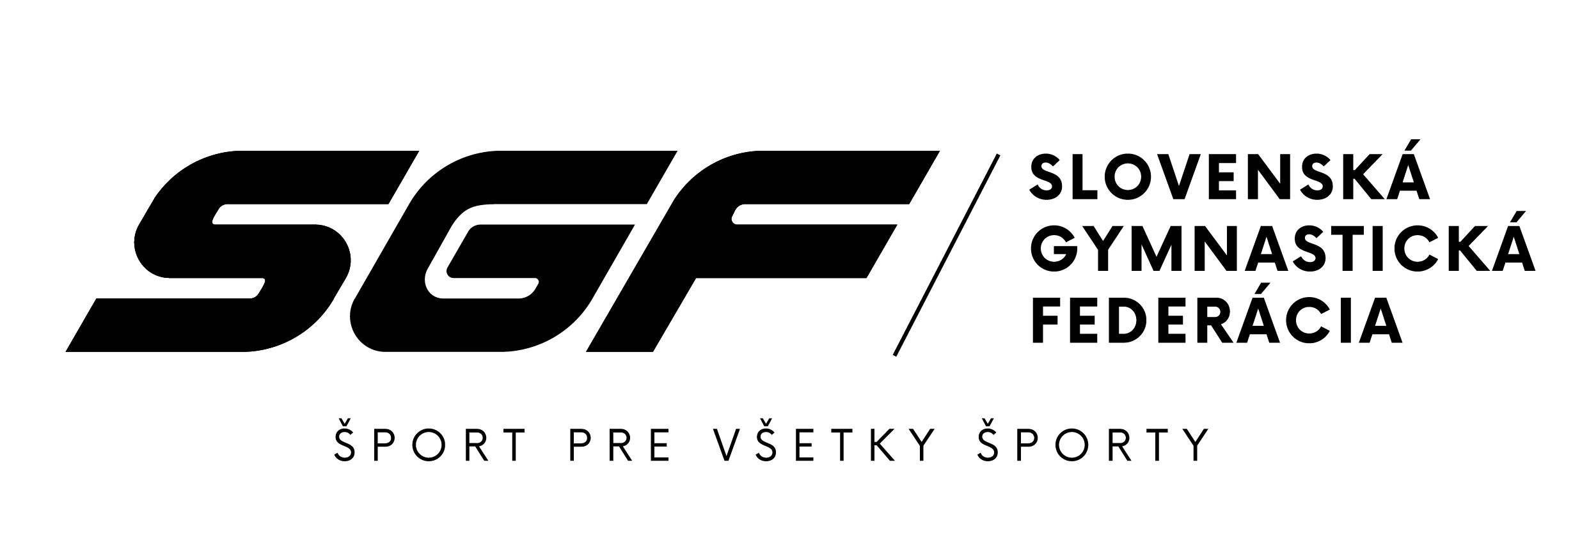
SLOVAK GYMNASTICS OPEN 2023
24th – 25th November 2023, Poprad (SVK)

Form to be sent to: zbynovacova@sgf.sk
Deadline: 25th September 2023
Organizing Committee / Host Federation
Slovak Gymnastics Federation
Junácka 6
832 80 Bratislava

Travel Schedule Form

Federation |  | Contact person:
Federation |  | Phone:
Federation |  | E-mail:
If the team delegation is scheduled on more than one transportation mean, please complete one (1) form for
each transportation mean. For earlier arrival or later departure please contact the OC.
Arrival information
# of persons |  |  | # of luggage
Date: |  |  |  |  | Arrival time
By airplane | Airport: |  |  | Flight # |  | From
By train | Station: |  |  | Train # |  | From
By bus | Station: |  |  | Bus # |  | From
By car

Departure information
# of persons |  |  | # of luggage
Date: |  |  |  |  | Departure time
By airplane | Airport: |  |  | Flight # |  | To
By train | Station: |  |  | Train # |  | To
By bus | Station: |  |  | Bus # |  | To
By car

Place and date | Seal of the NF | NF authorised signature
 |  | Signature of the President or Secretary General of the participating FIG affiliated NF

