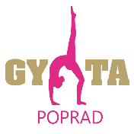
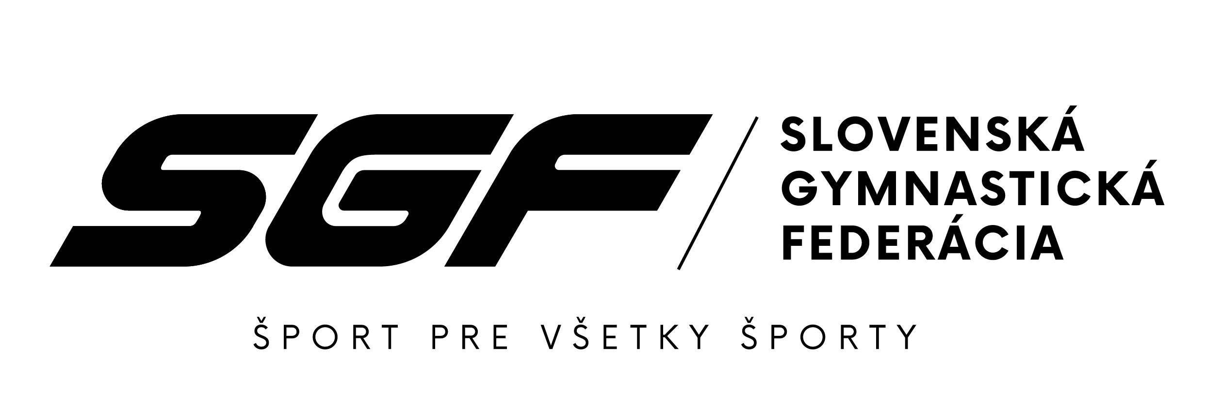
SLOVAK GYMNASTICS OPEN 2023
24th – 25th November 2023, Poprad

Form to be sent to:zbynovacova@sgf.sk

Organizing Committee / Host Federation
Slovak Gymnastics Federation
Junácka 6
832 80 Bratislava
Deadline: 5th September 2023

PRELIMINARY registration

Federation |  | Contact person:
Federation |  | Phone:
Federation |  | E-mail:

We will participate YES NO

If yes, with the following delegation:
YES NO
WAG SENIOR GYMNASTS………………………………………………………………………………….
WAG JUNIOR GYMNASTS………………………………………………………………………………….
WAG coaches………………………………………………………………………………………………….
WAG judge…………………………………………………………………………………………………….
MAG SENIOR GYMNASTS………………………………………………………………………………….
WAG JUNIOR GYMNASTS………………………………………………………………………………….
WAG coaches………………………………………………………………………………………………….
WAG judge……………………………………………………………………………………………………..
Additional persons: ……………………………………………………………………………………………

Place and date | Seal of the NF | NF authorised signature
 |  | Signature of the President or Secretary General of the participating FIG affiliated NF

