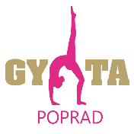
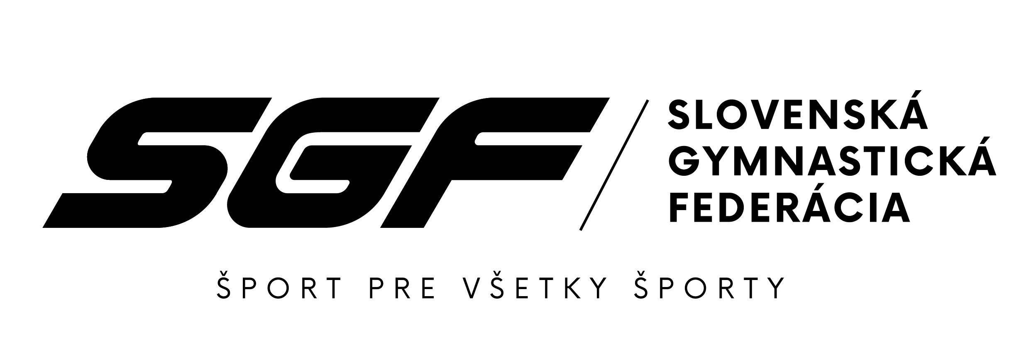

SLOVAK GYMNASTICS OPEN 2023
24th – 25th November 2023 Poprad (SVK)

Form to be sent to: zbynovacova@sgf.sk
Deadline: 25th September 2023
Organizing Committee / Host Federation
Slovak Gymnastics Federation
Junácka 6
832 80 Bratislava

ACCOMMODATION Form

Federation/Club |  | Contact person:
Federation/Club |  | Phone:
Federation/Club |  | E-mail:

Hotel name | Room type  (i.e. single/double/triple | Arr. day | Dept. day | LAST NAME,  First Name | Function | Price per  person per night | # of nights | Total
 |  |  |  |  |  | GRAND TOTAL

Special requirements

Place and date | Seal of the NF | NF authorised signature
 |  | Signature of the President or Secretary General of the participating FIG affiliated NF

