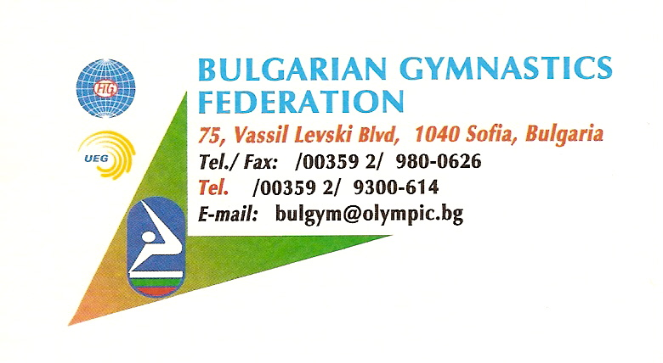
Dear Sports Friends,

Bulgarian Gymnastics Federation and Gymnastics Club “Lyubcho Solachky” have the pleasure to invite you to take part in17th International Clubs Tournament for Male and Female Artistic gymnastics, which will take place in the period from 26 to 28th November 2021 in Blagoevgrad, Bulgaria.
We do hope that this traditional sports event will realize its purposes to promote and expand the artistic gymnastics, involve gymnasts and specialists from different countries to exchange knowledge and experience in a friendly and warm atmosphere.
We would be very pleased to receive at this prestigious event some of the best gymnasts from all over the world. And we would be very happy to host you among our guests.
We are going to share with you our enthusiasm and you will help us to make this competition be the celebration of the grace and beauty.
Looking forward to seeing you in Bulgaria,
Best regards
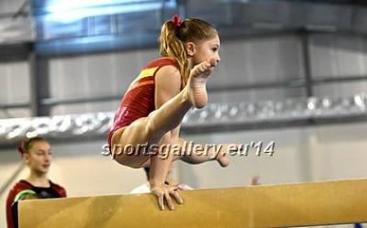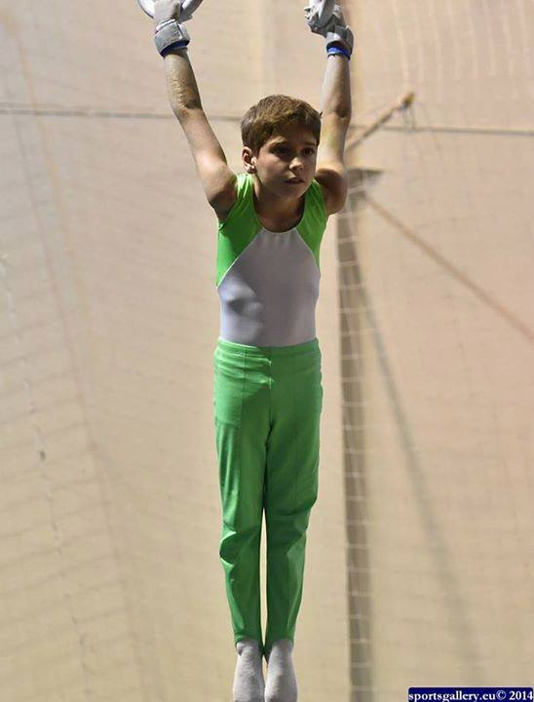
Competition Hall
Sports hall Scaptopara –
2700 Blagoevgrad
Zapad
Information for the city - http://en.wikipedia.org/wiki/Blagoevgrad; http://www.maplandia.com/bulgaria/blagoevgard/blagoevgrad/ ;http://www.blgmun.com/;

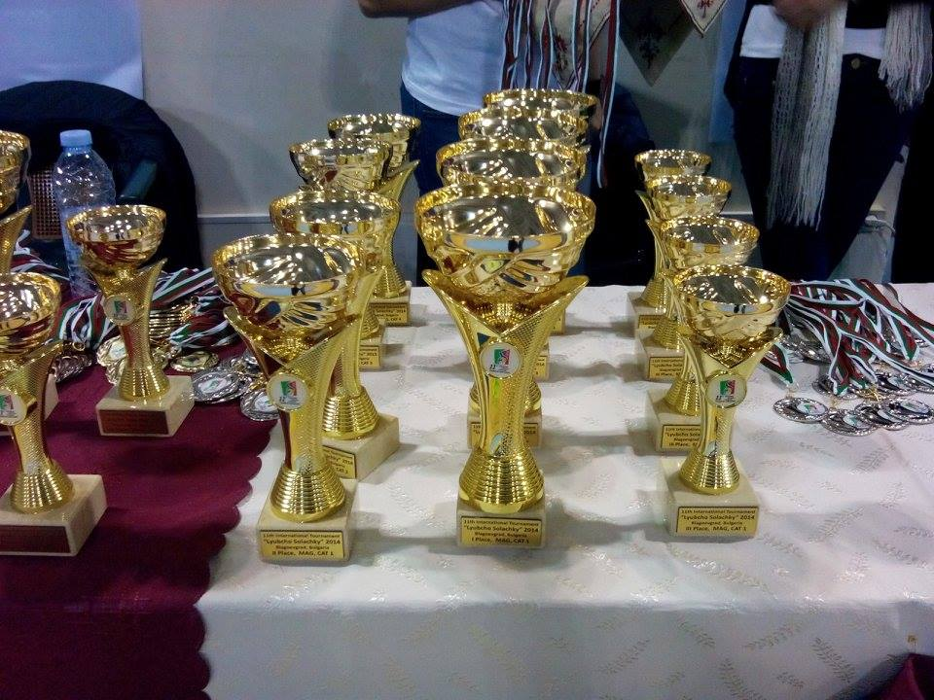

General Regulation
- Disciplines Men’s and Women’s artistic gymnastics.
- Apparatus supplier: Janssen & Fritsen for MAG and WAG Competitions.
- Provisional Schedule:
-Friday: 26.11.2021
^{1. Official day of arrival.}
^{2. Training.}
^{3. Orientation meeting.}
-Saturday: 27.11.2021
^{1. Competition day 1.}
-Sunday: 28.11.2021
^{1. Competition day 2.}
^{2. Departure.}
-Monday: 29.11.2021
^{1. Official day of departure.}
! Earlier arrival and later departure are possible!
- Individual Classification: medals offered to the first eight of each category.
- For the finals will be ranked maximum 2 gymnasts from each CLUB!
- Classification by team: A team is composed of three best all-around scores in category.
- Registration fee 15 € by gymnast.
- Fine- 50 € by club if you don’t have a judge in one of the genders (Both genders 100 €). If you have gymnast in Male and Female you should have Male judge and Female judge.
- Any payments may be made by bank transfer or in cash to the tournament organizers.
- Important Note: All events high is from FIG Directives. But for the categories 1 and 2 for Male and Female gymnasts can be used 20cm. mats under the following apparatus:
MAG- Still rings and High bar. (+soft mat)
WAG- Uneven bars and Beam. (+soft mat)
- Gifts for all gymnasts.
- Every delegation should send gymnastics age ID verifications.

Accommodation
Accommodation should be paid by the participants (for each member of delegation) the hotel is-
Contact us for more info.
Insurance
The organizer is not responsible for any liability in the case of accidents.
Therefore, all participants are advised to look for adequate insurance coverage.

Categories and Technical Program
- Male
# Gymnasts born 2013 and younger* (CAT 1). Executions from 10,00. Maximum count of elements(7+dismount) VAULT height – 100cm or more; 1 or 2 springboards; 2 different vaults or same. First vault score is going for All-Around and Team, The average score from both vaults is for Apparatus Finals!. Full intermediate swing is allowed once. Every gymnastics element out of code – 0,10
A – 0,30
B – 0,50
C – 0,70
D – 0,90

Dismounts: A – 0,30
B – 0.50
C – 0,70

# Gymnasts born 2012 – 2011 * (CAT 2). Executions from 10,00. Maximum count of elements(7+dismount) VAULT height – 110cm or more; 1 or 2 springboards; 2 different vaults. First vault score is going for All-Around and Team, the average score from both vaults is for Apparatus Finals! Full intermediate swing is allowed once.Every gymnastics element out of code – 0,10
A – 0,30
B – 0,50
C – 0,70
D – 0,90
Dismounts: A – 0,30
B – 0.50
C – 0,70

# Gymnasts born 2009- 2010* (CAT 3). Executions from 10,00. Maximum count of elements(7+dismount), VAULT height – 120cm or more; 1 or 2 springboards; 2 different vaults. First vault score is going for All-Around and Team, the average score from both vaults is for Apparatus Finals!
A – 0,10
B – 0,20
C – 0,30
D – 0,40…

Dismounts: B – 0,30
C – 0.50
D – 0,70

# Gymnasts born 2006– 2008 (CAT 4). By FIG (By Code of point for junior)
- Female

- Category 1, born 2013 and younger - Execution from 10,00. VAULT height – 100cm or more; 1 or 2 springboards; 2 different or same vaults. First vault score is going for All-Around and Team, The average score from both vaults is for Apparatus Finals!Full intermediate swing is allowed once. Every gymnastics element out of code – 0,10. CR - FIG – 1.00 except dismount.
A – 0,30
B – 0,50
C – 0,70

- Category 2, born 2011 - 2012. Execution from 10,00. VAULT height – 110cm or more; 1 or 2 springboards; 2 different vaults. First vault score is going for All-Around and Team, The average score from both vaults is for Apparatus Finals! Full intermediate swing is allowed once. CR – FIG 1.00 except dismount.

A – 0,30
B – 0,50
C – 0,70
D – 0,90

- Category 3, born 2009-2010- Execution from 10,00. VAULT height – 120cm or more; 1 springboard; 2 different vaults. First vault score is going for All-Around and Team, The average score from both vaults is for Apparatus Finals!CR and CV – FIG, except dismount.

- Category 4, born 2006 – 2008 FIG Rules for Juniors

IMPORTANT NOTE!- Vault high can be 125cm. or more

Deductions for short exercises – WAG:

 | CAT 1* and 2 | CAT 3 | CAT 4
Uneven bars | 5 elements(includes dismount)  5 elements – 10.00  4 elements – 8.00  3 elements – 4.00  2-1 elements – 2.00 | 6 elements  (includes dismount )  6 elements – 10.00  5 elements – 8.00  4 elements – 4.00  3 elements – 2.00  2-1 elements – 1.00 | FIG rules for JUNIORS
Balance Beam | 8 elements (includes dismount) | 8 elements (includes dismount) | FIG rules for JUNIORS
Floor Exercise | 8 elements (includes dismount) | 8 elements (includes dismount) | FIG rules for JUNIORS

*CAT 1 on UB can use only high bar.

IMPORTANT NOTE: TEAMS CONSIST OF 3 COMPETITORS PER CATEGORY!

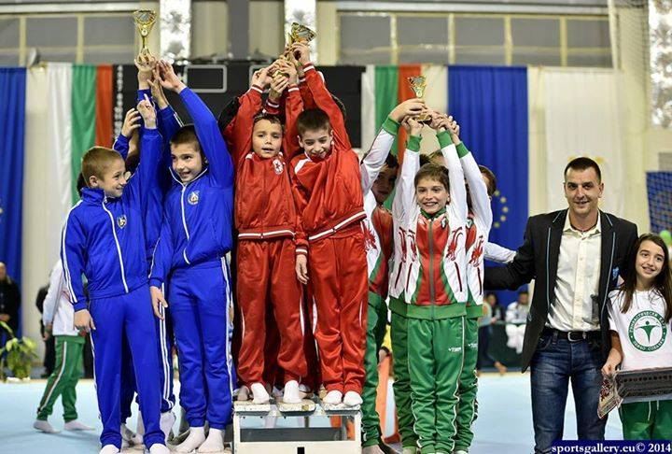

Blagoevgrad 2021
17th International Clubs Tournament
“Liubcho Solachky”

PROVISIONAL ENTRY FORM
DEADLINE: 1 October 2021
Please, send this form to:

Bulgarian Federation Organizing Committee
Tel./Fax +359 2 980-0626 Mr. Sakho Siradeghyan
Phone: +359 896 349 955
E-mail: lsolachky@abv.bg

Club …………………………………………………………………………………………………….
Federation ………………………………………………………………………………….................
Contact person ………………………………………………………………………………………..
Name, Surname, Function
Tel. ………………………….. Fax…………………………. e-mail …….………………………
 | Number of participants
Male Gymnasts
Woman Gymnasts
Coaches
Judges | M- | F-
Others
Total of persons in delegation

Date: ……………………………… Signature and stamp ……………………..

Blagoevgrad 2021
17th International Clubs Tournament
“Liubcho Solachky”
DEFINITIVE ENTRY FORM
DEADLINE: 1 October 2021

Please, send this form to:
Bulgarian Federation Organizing Committee
Tel./Fax +359 2 980-0626 Mr. Sakho Siradeghyan
Phone: +359 896 349 955
E-mail: lsolachky@abv.bg

Club …………………………………………………………………………………………………….
Federation ………………………………………………………………………………….................
Contact person ………………………………………………………………………………………..
Name, Surname, Function
Tel. ………………………….. Fax…………………………. e-mail …….………………………

 | Gymnasts | Male | Year of birth
1
2
3
4
5
6
7
8
9
10

Blagoevgrad 2021
17th International Clubs Tournament
“Liubcho Solachky”

ARRIVAL AND DEPARTURE FROM
Deadline: 10 October 2021
Please, send this Form together with the Provisional Entry Form to the OC:
Organizing Committee
Mr. Sakho Siradeghyan
Phone: +359 896 349 955
E-mail: lsolachky@abv.bg

Club …………………………………………………………………………………………………….
Federation ………………………………………………………………………………….................
Contact person ……………………………………………………………………………………….
Name, Surname, Function
Tel. ………………………….. Fax…………………………. e-mail …….………………………

Arrival Departure

Date ……… …………………… Date ………… ………………….

Airport Railway station Airport Railway station

Blagoevgrad Bus Station Blagoevgrad Bus Station
Hour …………………………………... Hour ……………………………………
Flight // Train // Bus Flight // Train // Bus
No……………………………………. No……………………………………..
From ………………………………….. To ……………………………………..
Number of persons…………………. Number of persons ………………….
Date: ………………………… Signature and stamp ………………………..

